FIGHTING FIRE WITH FIRE
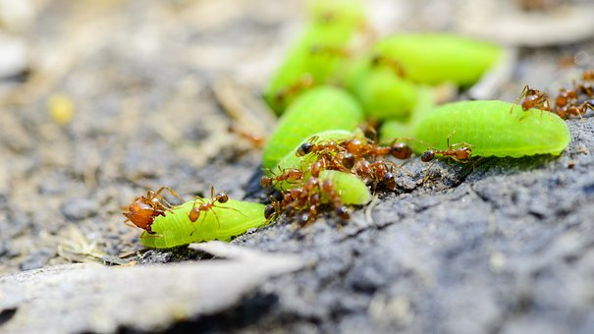
By niamh williams DATE august 2018

Image from pixabay

Fire ants and ‘crazy’ ants are two different species of ant that both originate from South America but were introduced to the USA in the 20th century, causing problems for other species because of their aggressive tactics. Now scientists at the University of Texas in Austin have reported their findings of what happens when these different species of ant come face to face.

Fire ants produce venom when they sting, which can be lethal to many different types of insect and can be extremely painful to humans. Tawny crazy ants form giant colonies, often inside homes, including inside electrical appliances! Crazy ants don’t sting but they do run around in all directions when they are under threat or excited, which is where their name originated from.

Exterminators were noticing that crazy ants were managing to not only survive attacks by fire ants but actually managing to displace them, leading scientists to question how they were able to do this. The scientists at the University of Texas set up a series of experiments where they lured both types of ant to the same place, to observe what would happen.

The fire ants arrived at the food source first, followed by the crazies. When the crazy ants arrived, they sprayed the fire ants with formic acid, which spouted from a small opening in their abdomens. The fire ants responded by producing their venom, covering the crazy ants. What happened next was what the scientists found it most interesting.

Once they had been covered in venom, the crazy ants retreated and curled up as small as possible. They excreted formic acid onto their mandibles (which are pincer-like parts of their heads) and used these to groom themselves, covering their whole bodies in formic acid. The acid worked to neutralise the venom from the fire ants, protecting the crazy ants from being harmed by the venom, and resulting in a survival rate of 98 %.

To make sure it was the formic acid having this effect, the investigators used a group of crazy ants with clear nail varnish painted over the openings on their abdomens. This meant they could not produce the formic acid. While 98% of crazy ants that were able to produce formic acid survived, only 49% of crazy ants that could not produce formic acid survived.

While these results are interesting and shed light on how the crazy ants may affect the populations of fire ants, scientists warn that these crazy ants can still be dangerous themselves. They gather in huge numbers and can be extremely difficult to get rid of once they have set up camp in someone’s home.

Answer the following questions in full sentences:
- What is this news story about?
_______________________________________________________________________________
_______________________________________________________________________________
_______________________________________________________________________________

- Explain why the investigators used a group of ants with nail polish painted over their abdomen.
_______________________________________________________________________________
_______________________________________________________________________________
_______________________________________________________________________________

- Describe the results of the investigation.
_______________________________________________________________________________
_______________________________________________________________________________
_______________________________________________________________________________

- Suggest the pH range that the fire ant venom would fall into.
_______________________________________________________________________________

- Write down the meanings of any words in bold in the article.
_______________________________________________________________________________
_______________________________________________________________________________
_______________________________________________________________________________
_______________________________________________________________________________
_______________________________________________________________________________
_______________________________________________________________________________

